EPREL Dataconverter

Manual

Inhalt
Version History 3
File Source 4
References 4
System requirements 5
Installation 5
EPREL Dataconverter 5
Main Window 5
Tools Window 8
Excel Template 8
Application process 10
Parsing Error 10
Generating Error 10
Tools 10
Attachments 11
Product Model Content Structure 11

Version History

Version 1.1.17
. change of some language issues
. added links
. compliance to current EC regulation Light sources parameters (2019/2015)

Version 1.1.16
. Changed CONSIDER_GENERATED_LABEL_AS_PROVIDED to USE_SUPPLIER_UPLOADED_LABEL
. added TECHNICAL_PARAMETERS and child XML Keys to the Group

Version 1.1.15
. Disclaimer Welcome Screen
. Changed Round to Ceiling
. Added Manual
. Download process info
. Parsing process info
. XML Generating info

Version 1.1.14
. Disabled free text trademark according to EPREL 1.53.0
https://webgate.ec.europa.eu/fpfis/wikis/pages/viewpage.action?pageId=897385478
. Template updated to V0.6 - !PLEASE USE NEW VERSION!
- Changes in round up ENERGY_CONS_ON_MODE
(Excel rounded down all values below x,5 new version corrected to round up all decimals)
- Changed columns in DOWNLOAD sheet

Version 1.1.13
. Added Error support in Excel Paring with row, column and sheet
. (REGISTER_PRODUCT_MODEL)
. Added DECLARE_END_DATE_OF_PLACEMENT_ON_MARKET Module
. Added Tools Section
. Added Download Labels and Fiches
. Template Updated to V0.5

Version 1.1.12
. Added Error support in Excel Paring with row, column and sheet
(REGISTER_PRODUCT_MODEL)

Version 1.1.11
. BugFix
REGISTRATION parsed R9 value from wrong column

Version 1.1.10
. Excel Template changed
. Tools in Debug Mode Available

Version 1.1.9
. Bug in Excel Parsing Fixed

Version 1.1.8
. R9 Value -100 to 100

Version 1.1.7:
. Reason for Change Typo fixed
. EPREL Registration Number Changed to String

Version 1.1.6:
. FLUORESCENT typo
. Updated Product Update
. Updated Template V03

Version 1.1.5:
. New Template V0.2
. added Try/Catch to Registration
. Error message while error on Parsing
. adding Nature of registrant
. added Error handling
. added full LAMP support for PRODUCT_MODEL_REGISTRATION
. Registration with contact reference is working

Release 1.0.1
. LogFile
. BugFixes
. Waiting Cursor
. Save File Dialog improved

File Source
https://github.com/mplnck/EPREL_Dataconverter/raw/master/EPREL%20Dataconverter%20Setup/Release/EPREL%20Dataconverter%20Setup.msi

References
- EPREL - User Guide - 02 Model registration - https://webgate.ec.europa.eu/fpfis/wikis/display/EPREL/EPREL+Exchange+Model+Documentation?preview=/816809981/816809990/ProductModelExchangeModel.pdf - 27.09.2021
- ProductModelExchangeModel - https://webgate.ec.europa.eu/fpfis/wikis/download/attachments/285088651/EPREL%20-%20User%20Guide%20-%2002%20Model%20registration%20-%20File%20upload%20v1.80.docx?version=1&modificationDate=1631190115548&api=v2 – 27.09.2021

System requirements
Operating System Windows 10
Required Software Microsoft Excel
Browser Mozilla Firefox

Installation
Please download the latest installer from the installation source and follow the instructions in the assistant.

EPREL Dataconverter
To launch the EPREL Dataconverter application, double-click its desktop icon, or choose Start > Programs > nimbus Group GmbH > EPREL Dataconverter from the Start menu.

Main Window
After starting the application, you need to accept the disclaimer, after this, you will see the main window with following options.
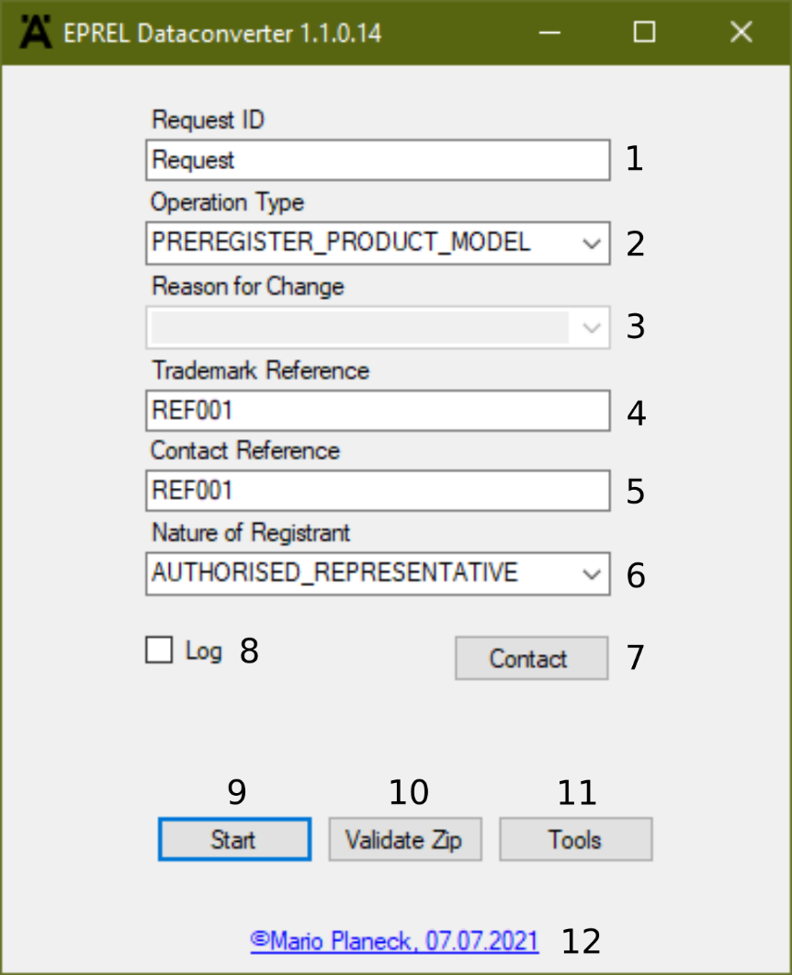
Figure 1Main Window

- ID of the transaction to be provided by the supplier. It is a free text, but XML reserved characters must be avoided (i.e. &, <, >, etc.)
- There is one operation for each model to create. This section will be repeated as many times as operations (models to create/update/etc.) needed.
Available operations to perform on a product model:
- REGISTER_PRODUCT_MODEL: Legal registration of a product model (compliance data + energy label + product information sheet).
- UPDATE_PRODUCT_MODEL: Correction of a legal declaration of product model information accordingly to the Article 12(10) of the EU regulation 2017/1369. This operation can only be used to correct errors or to complete an existing product model (in case of pre-registration for example). This operation must not be used in case of changes made on a product that are relevant for the label or the product information (Article 4 (12) of the EU regulation 2017/1369). In that case, a new product model shall be registered.
- DECLARE_END_DATE_OF_PLACEMENT_ON_MARKET: Declaration of starting date of the 15 years retention period of compliance data. (ON_MARKET_END_DATE) Article 4(6) and 16(q) of the EU regulation 2017/1369.
- PREREGISTER_PRODUCT_MODEL: Operation used to early get an EPREL_PRODUCT_MODEL_ID that could be used to generate a QR Code. This operation could be useful for suppliers who would like to prepare the packaging of their goods with the energy label a long time before putting their products on the EU market.
- Only needed for the operation of type "UPDATE_PRODUCT_MODEL" when the latest version of the product model is already in status "PUBLISHED" in EPREL.
- CORRECT_TYPO: supplier has done a mistake when declaring a value and needs correction.
- CHANGE_IN_STANDARDS: the testing standards can change and some values need to be modified.
- LABEL_SCALE_RANGE_CHANGE: In a same Delegated Regulation the scale of energy efficiency may change with the years (i.e. Reversible air conditioners classified in energy efficiency classes A - G from 01/01/2013 to 31/12/2014, A+ - F from 01/01/2015 to 31/12/2016, etc.) and model needs to be modified.
- CHANGE_REQUESTED_BY_MSA: If MSA detects an error or mistake that does not need a new model registration, it can ask the supplier to modify some values of a registered model.
- ADDED_INFORMATION_NO_EFFECT_ON_DECLARATION: During the lifecycle of a model it might be, that either the company itself produces more helpful information, or clarification, or that it turns out that for communication with MSA this information speeds up their understanding (though strictly speaking not legally necessary). Additional information, that does not change in such a case the model, this cannot lead to a forced change in model number (=no new registration), a change of model would then not make any sense.
- REQUEST_CHANGE_BY_EXTERNAL_BODY: A Certification Body very frequently detect errors in declared data, sometimes typing mistakes, many times performance data which, after test in Independent Laboratory, need correction (“re-rating”). Data linked to a product can represent up to dozens of values, and it can happen that one, a few, or more, need adjustment. New models each time is not sustainable.
There is another reason for change in the UI, which is to set the date of end of placement on the market, but it is not necessary in system- to-system because there is a special operation for doing it (DECLARE_END_DATE_OF_PLACEMENT_ON_MARKET).
- The value must refer to a Trademark reference (internal code) defined centrally in the EPREL database. Advantage of this option is that trademark names cannot be misspelled as they are defined once at organisation level. The name of the trademark with this reference will be used on generated energy labels and product fiches.
- Reference to the contact defined in the EPREL database. If the reference not specified, a fall back strategy is applied.
The system uses "CONTACT_REFERENCE" and links the product to the related contact found in its DB.
  - If the CONTACT_REFERENCE cannot be found in the database or this reference is related to a department or organisation that is out of the scope of the submitting system => the registration of the model is rejected.
  - If the reference is not specified, the system tries to link the product model to the contact defined at the level of the department (If more than one contact defined at department level => the registration of the model is rejected)
  - If the product mode is not linked to a department, the system tries to link the product model to the contact defined at organisation level.
If more than one contact is defined at organisation level or if there's no contact defined => the registration of the model is rejected.

The reference of the contact detail can be retrieved either directly from the EPREL-compliance web application or via the ReferenceDataService.
- Suppliers can be of three type (Manufacturers and/or Importers and/or Authorised representative). When registering a model supplier has to indicate with which hat he is registering. If supplier has only one type assigned, this type will be set by default; if supplier is of multiple types, this field will have to be informed.
Possible values:
- MANUFACTURER
- IMPORTER
- AUTHORISED_REPRESENTATIVE
- The contact details using the structure “ModelSpecificContactDetails” defined in the model.
THIS OPTION WILL NOT BE AVAILABLE IN A NEAR FUTURE. ONLY CONTACTS BY REFERENCE WILL BE ALLOWED WHEN REGISTERING/UPDATING MODELS. PLEASE USE REFERENCE.
- Shows the LOG. If you have trouble check the log before you contact support. Usually it gives a hint where the problem is.
- Run the process (please make sure you have a fully filled Excel sheet (ref. Application process) )
- If you already have a zip file you can validate the zip file in its structure.
- Tools
- Date of version release. Link to support

Tools Window
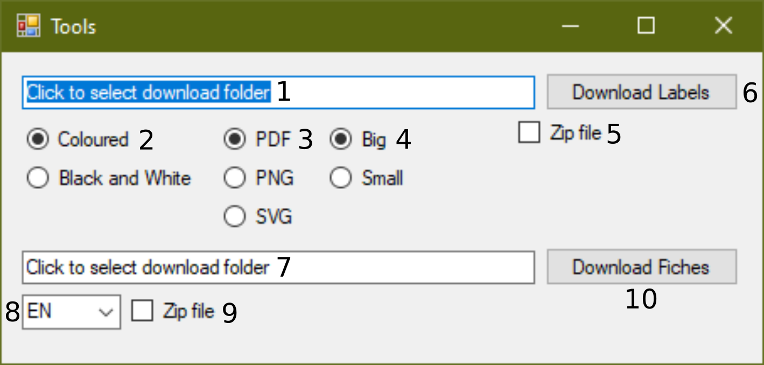
Figure 2Tools Window
- Click to select folder, where the labels should be downloaded
- Select colour type of the labels
- Select file format for the labels
- Select size type for the labels
- Select, if all data (all colour, all size, etc.) should be downloaded
- Start download process for labels
- Click to select folder, where the fiches should be downloaded
- Select specific language
- Select, if all languages should be downloaded
- Start download process for fiches

Excel Template
To use the EPREL Dataconverter properly, you need to fill the excel template. The template can be found in the installation folder. If the installation folder was not changed within the installation process, the file is located:
C:\Program Files (x86)\nimbus Group GmbH\EPREL Dataconverter Version 1.1.14\Vorlage_EPREL_ECO-V0.6.xlsx
For each operation type you need to fill out the specific sheet. The arrangement of the columns must not be changed. It is possible to add as much columns at the end of the table but not in between.
The data for the products must start in row 2. Also there must no blank lines between the products which should be registered. For more information filling the Excel sheet refer to Product Model Content Structure in the Attachments area.
For a successful REGISTER_PRODUCT_MODEL and UPDATE_OPERATION the technical documentation is mandatory. For this part please switch to the sheet attachments.
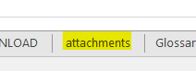
Figure 3Attachment sheet
For each MODEL_IDENTIFIER you need to upload a document out of each category except ADDITIONAL_PART.
Key | Field | Obligation | Type | Description
MODEL_IDENTIFIER | Supplier's model identifier | M | Text | Model identifier of the product model.
DESCRIPTION | Document description | Calculated by spreadsheet | Text | Description of the File being uploaded to EPREL
LANGUAGE | Language | M | Language Code | Language of the document. If two or more languages apply, separate with semicolon (e.g. DE;EN)
ADDITIONAL_PART | Additional information | O | Boolean | In addition, the supplier may upload additional parts of the technical documentation on a voluntary basis into the database.
CALCULATIONS | Calculations | M | Boolean | Calculations performed with the measured parameters
GENERAL_DESCRIPTION | General information | M | Boolean | A general description of the model, sufficient for it to be unequivocally and easily identified
MEASURED_TECHNICAL_PARAMETERS | Measured data | M | Boolean | Measured technical parameters of the model
REFERENCES_TO_HARMONISED_STANDARDS | References to harmonised standards | M | Boolean | References to the harmonised standards applied or other measurement standards used
TESTING_CONDITIONS | Testing conditions | M | Boolean | Testing conditions if not described sufficiently in REFERENCES_TO_HARMONISED_STANDARDS
SPECIFIC_PRECAUTIONS | Precautions | M | Boolean | Specific precautions that shall be taken when the model is assembled, installed, maintained or tested
FILE_NAME | File name | M | Text | Filename to be uploaded. The allowed formats for the attachments are *.PDF, *.TXT, *.DOCX, *.RTF, *.XLSX, *.PPS.
Table 1Attachment description
Figure 4Attachment example

It is possible to register multiple documents for one MODEL_IDENTIFIER like in row 2 and 3 as seen in Figure 4 or multiple categories for one MODEL_IDENTIFIER.

Application process
After successfully filling the template a full process will be possible. After pressing the Start button in the main window the applications ask for choosing an Excel file. Please choose the file with the filled information based on the provided template.
In the next step the application will parse the Excel data and convert it into an XML file. In this process two possible errors may occur.

Parsing Error
Please check the data in the Excel file. The applications were not able to go through the cells of the spreadsheet. Usually the log will help in which column or cell the mistake is placed (ref. Figure 5).
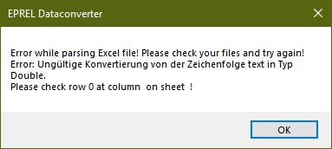  Figure 5Parsing error | 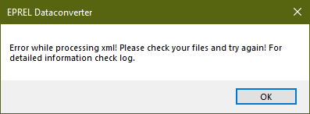  Figure 6XML Error

Generating Error
If the provided data in the cells are not correct (e.g. Type must be text but the cell is filled with a numeric value) the application will give a hint in the Log where the mistake Is (ref. Figure 6)
This process will take a while until the application will ask you, where to save the generated ZIP file.
IMPORTANT! Please do not change the name of the file. It must be named productModelRegistrationTable.zip
In the next step the application needs the folder where all technical documentation is located. Please make sure, that the spectral files and technical documentation is located in one folder, without subfolders. The application will load them in the Zip file and organise it as necessary. Additionally, you can validate your ZIP file in the next step. After successfully running the software the zip file can now be uploaded into the EPREL Database.

Tools
Before using the download tool some preparations need to be done. In the spreadsheet based on the template the sheet DOWNLOAD must be filled with the EPREL_REGISTRATION_NUMBER and MODEL_IDENTIFIER. The tool only downloads the data for the MODEL_IDENTIFIERS filled in this sheet.

Attachments

Product Model Content Structure
The following table is a helping hand for filling the Excel template. The data is based on the guides provided by the European Commission. Please check the current version.
M = Mandatory
O = Optional
H = Hide
D = Disabled
Key | Field | Obligation | Type | Length/  Range | Format | Unit | Observations
General Information0
EPREL_MODEL_REGISTRATION_NUMBER | Registration number | O | Unsigned long |  |  |  | Unique identifier determined at registration time by the EPREL system.  This registration number is candidate to be the dynamic part of the link that would present as a QR code in future Energy labels.  This registration number is generated by the EPREL at creation time and therefore must not be provided for operations  - REGISTER_PRODUCT_MODEL  - PREREGISTER_PRODUCT_MODEL  The EPREL registration number become mandatory for operations  - UPDATE_PRODUCT_MODEL  - DECLARE_END_DATE_OF_PLACEMENT_ON_MARKET
MODEL_IDENTIFIER | Supplier's model identifier | M | Text | 255 |  |  | Model identifier of the product model.
CONSIDER_GENERATED_LABEL_AS_PROVIDED | Kind of providing the label | M | Boolean | true/  false |  |  | Suppliers have to provide Energy labels. The label must also be generated from the EU database.  As these two obligations can be considered as redundant, suppliers can decide to consider labels generated by the EC database as labels provided in their own.  By setting the value of the Boolean attribute to TRUE, the supplier request the label, generated from the EC database, to be considered as if it was provided by itself.
ON_MARKET_START_DATE | Date of placement on the market | M | Date |  | dd.mm.yyyy |  | Date on which the model will be/has been placed on the market (or put into service).  Since neither the public, the EC nor MSAs will be able to access to product details before this date the registration will not be considered as effective until the ON_MARKET_START_DATE has been reached.
ON_MARKET_END_DATE | Date of end of placement on the market | O | Date |  | dd.mm.yyyy |  | Date after which the final unit of the model has been placed on the market.  This date does not have to be provided at registration time.  This date will be mainly used to evaluate the retention period as described in EU Regulation 1369/2017 - Article 4.6.
VISIBLE_TO_UK_MSA | Compliance data visible to UK MSA | O | Boolean |  | true/false |  | Optional flag to indicate if the product compliance information (technical documentation, equivalents and ICSMS data) should be visible to the Market Surveillance Authority for the United Kingdom.  The handling of the flag is the following:  - For suppliers based at UK/Northern Ireland: if the flag is omitted, it is considered as being "true" by default. If the flat is sent as "false", an error will occur.  - For suppliers based at an EU country: if the flag is omitted, it is considered as being "false" by default.
Lighting Technology
LIGHTING_TECHNOLOGY | Lighting technology used | M | List | HL, LFL_T5_HE, LFL_T5_HO, CFLNI, OTHER_FL, HPS, MH, OTHER_HID, LED, OLED, MIXED, OTHER |  |  | List of technologies (Annex V Table 3):  HL = HL  LFL T5 HE = LFL_T5_HE  LFL T5 HO = LFL_T5_HO  CFLni = CFLNI  other FL = OTHER_FL  HPS = HPS  MH = MH  other HID = OTHER_HID  LED = LED  OLED = OLED  mixed = MIXED  other = OTHER
DIRECTIONAL | Non-directional or directional | M | List | NDLS, DLS |  |  | NDLS = Non-directional  DLS = Directional
CAP_TYPE | Light source cap-type (or other electric interface) | M | Text | 255 |  |  | Free text
MAINS | Mains or non-mains | M | List | MLS, NMLS |  |  | MLS = Mains  NMLS = Non-mains
CONNECTED_LIGHT_SOURCE | Connected light source (CLS) | M | Boolean | true/false
COLOUR_TUNEABLE_LIGHT_SOURCE | Colour-tuneable light source | M | Boolean | true/false
Depending on the lighting technology used ENVELOPE might be mandatory:
IF [LIGHTING_TECHNOLOGY] = MIXED THEN M
IF [LIGHTING_TECHNOLOGY] = OTHER_HID THEN M
IF [LIGHTING_TECHNOLOGY] = HPS THEN M
IF [LIGHTING_TECHNOLOGY] = MH THEN M
IF [LIGHTING_TECHNOLOGY] = Others value/NULL then H
ENVELOPE | Envelope | M/H | List | NO, SECOND, NON_CLEAR, SECOND_NON_CLEAR |  |  | List of envelopes:  NO = No  SECOND = Second  NON_CLEAR = Non-clear  SECOND_NON_CLEAR = Second + Non-clear
END IF [LIGHTING_TECHNOLOGY]
HIGH_LUNINANCE_LIGHT_SOURCE | High luminance light source | M | Boolean | true/false
ANTI_GLARE_SHIELD | Anti-glare shield | M | Boolean | true/false
DIMMABLE | Dimmable | M | List | YES, NO, SPECIFIC |  |  | List of dimmable:  YES = Yes  NO = No  SPECIFIC = Only with specific dimmers
General product parameters
ENERGY_CONS_ON_MODE | Energy consumption in on-mode | M | Number (No decimals) | 1 - 99999 | ##### | KWh/1000h | Will be calculated within the Excel sheet. Please check correctness before uploading to the EPREL database.
ENERGY_CLASS | Energy Efficiency Class | M | List | A - G |  |  | List of classes (Annex II Table 1)  A, B, C, D, E, F, G  Will be calculated within the Excel sheet. Please check correctness before uploading to the EPREL database.
LUMINOUS_FLUX | Useful luminous flux | M | Number (No decimals) | 1 - 999999 | ###### | lm | In fiche will be shown together with beam angle:  [value] in [Sphere (360°)/Wide cone (120°)/Narrow cone (90°)]
BEAM_ANGLE_CORRESPONDENCE | Beam angle correspondence | M | List | SPHERE_360, WIDE_CONE_120, NARROW_CONE_90 |  |  | List of beam angle correspondences:  - SPHERE_360: Sphere (360°)  - WIDE_CONE_120: Wide cone (120°)  - NARROW_CONE_90: Narrow cone (90°)
CORRELATED_COLOUR_TEMP_TYPE | Correlated colour temperature type | M | List | SINGLE_VALUE, RANGE, STEPS |  |  | Correlated colour temperature, rounded to the nearest 100 K, or the range of correlated colour temperatures, rounded to the nearest 100 K, that can be set.  Options:  SINGLE_VALUE - Single value  RANGE - Range  STEPS - Steps
IF [CORRELATED_COLOUR_TEMP_TYPE] = SINGLE_VALUE then [CORRELATED_COLOUR_TEMP_SINGLE] = M
CORRELATED_COLOUR_TEMP_SINGLE | Correlated colour temperature | M | Number (No decimals) | 1 - 99999 | ##### | K | Correlated colour temperature, rounded to the nearest 100 K, or the range of correlated colour temperatures, rounded to the nearest 100 K, that can be set.  Values will end in "00", i.e. 99900 (No validation)
END if [CORRELATED_COLOUR_TEMP_TYPE] = SINGLE
If [CORRELATED_COLOUR_TEMP_TYPE] = RANGE THEN [CORRELATED_COLOUR_TEMP_MIN] = M AND [CORRELATED_COLOUR_TEMP_MAX] = M
CORRELATED_COLOUR_TEMP_MIN | Correlated colour temperature | M | Number  (No decimals) | 1 - 99999 | ##### | K | Correlated colour temperature, rounded to the nearest 100 K, or the range of correlated colour temperatures, rounded to the nearest 100 K, that can be set.  Values will end in "00", i.e. 99900 (No validation)  If type is Range then add 2 steps - fill the range (min-max)  Fiche will show X...X
CORRELATED_COLOUR_TEMP_MAX | Correlated colour temperature | M | Number  (No decimals) | 1 - 99999 | ##### | K
END IF [CORRELATED_COLOUR_TEMP_TYPE] = RANGE
If [CORRELATED_COLOUR_TEMP_TYPE] = STEPS THEN allow n (minimum 1)
CORRELATED_COLOUR_TEMP_1 | Correlated colour temperature | M | Number  (No decimals) | 1 - 99999 | ##### | K | Correlated colour temperature, rounded to the nearest 100 K, or the range of correlated colour temperatures, rounded to the nearest 100 K, that can be set.  Values will end in "00", i.e. 99900 (No validation)  If type is Steps then add as many steps as necessary.  Fiche will show: X or X (or X...)
… | … | … | … | … | … | …
CORRELATED_COLOUR_TEMP_n | Correlated colour temperature | M | Number  (No decimals) | 1 - 99999 | ##### | K
END IF [CORRELATED_COLOUR_TEMP_TYPE] = STEPS
POWER_ON_MODE | On-mode power | M | Number (1 decimals) | 0.1 - 9999.9 | ####.# | W
POWER_STANDBY | Standby power | M | Number (2 decimals) | 0.00 - 0.99 | #.## | W | Annex VI 1(e )6 -> ‘standby power (Psb) in W, including when it is zero;  Max value: 0.50 (No validation)
IF [CONNECTED_LIGHTSOURCE] = CLS THEN M
ELSE NULL
POWER_STANDBY_NETWORKED | Networked standby power for CLS | M | Number (2 decimals) | 0.00 - 0.99 | #.## | W | This field is only for Connected light sources
END IF [CONNECTED_LIGHTSOURCE]
COLOUR_RENDERING_INDEX | Colour rendering index | O  This field AND/OR Min/Max must be filled | Number (No decimals) | 1 - 100 | ### |  | Max value: 100  Fill this value or the range (min-max) below
MIN_COLOUR_RENDERING_INDEX | Colour rendering index range (Minimum) | O  Previous field AND/OR Min/Max must be filled | Number (No decimals) | 1 - 100 | ### |  | Max value: 100  Fill this value or the range (min-max) below
MAX_COLOUR_RENDERING_INDEX | Colour rendering index range (Maximum) | O  Previous field AND/OR Min/Max must be filled | Number (No decimals) | 1 - 100 | ### |  | Max value: 100  Fill this value or the range (min-max) below
DIMENSION_HEIGHT | Outer dimensions (Height) | M | Number (No decimals) | 1 - 99999 | ##### | mm | Outer dimensions without separate control gear, lighting control parts and non-lighting control parts, if any
DIMENSION_WIDTH | Outer dimensions (Width) | M | Number (No decimals) | 1 - 99999 | ##### | mm
DIMENSION_DEPTH | Outer dimensions (Depth) | M | Number (No decimals) | 1 - 99999 | ##### | mm
SPECTRAL_POWER_DISTRIBUTION_IMAGE | Spectral power distribution in the range 250 nm to 800 nm, at full-load | M | Text | 255 |  |  | Path to image of the graphic attached.  Image file:  In common image format (JPG, PNG, TIFF, SVG).  Size of file limited to maximum 2 Mb  Resolution minimum 1024x1024 px
CLAIM_EQUIVALENT_POWER | Claim of equivalent power | M | Boolean | Yes/Not applicable |  |  | Yes = TRUE  Not applicable = FALSE  'yes': An equivalence claim involving the power of a replaced light source type may be given only:  – for directional light sources, if the light source type is listed in Table 4 and if the luminous flux of the light source in a 90 ° cone (Φ90°) is not lower than the corresponding reference luminous flux in Table 4. The reference luminous flux shall be multiplied by the correction factor in Table 5. For LED light sources, it shall be in addition multiplied by the correction factor in Table 6;  – for non-directional light sources, the claimed equivalent incandescent light source power (rounded to 1 W) shall be that corresponding in Table 7 to the luminous flux of the light source.  The intermediate values of both the luminous flux and the claimed equivalent light source power (rounded to the nearest 1 W) shall be calculated by linear interpolation between the two adjacent values.
IF [CLAIM_EQUIVALENT_POWER] = TRUE THEN M
ELSE H
EQUIVALENT_POWER | Equivalent power | M | Number (No decimals) | 1 - 99999 | ##### | W | Only if CLAIM_EQUIVALENT_POWER = TRUE
END IF [CLAIM_EQUIVALENT_POWER]
CHROMATICITY_COORD_X | Chromaticity coordinate (x) | M | Number (3 decimals) | 0.001 - 0.999 | #.###
CHROMATICITY_COORD_Y | Chromaticity coordinate (y) | M | Number (3 decimals) | 0.001 - 0.999 | #.###
IF [DIRECTIONAL] = DLS then [PEAK_LUMINOUS_INTENSITY] = M AND [BEAM_ANGLE] = O AND/OR [MIN_BEAM_ANGLE]/[MAX_BEAM_ANGLE] = M
IF [DIRECTIONAL] = NDLS THEN [PEAK_LUMINOUS_INTENSITY] = NULL AND [BEAM_ANGLE] = NULL AND [MIN_BEAM_ANGLE] = NULL AND [MAX_BEAM_ANGLE] = NULL
Parameters for directional light sources
PEAK_LUMINOUS_INTENSITY | Peak luminous intensity | M | Number (No decimals) | 1 - 999999 | ##### | cd
BEAM_ANGLE | Beam angle | O  This field AND/OR Min/Max must be filled | Number (No decimals) | 1 - 180 | ### | degrees | Fill this value or the range (min-max) below
MIN_BEAM_ANGLE | Beam angle range (Minimum) | O  Previous field AND/OR Min/Max must be filled | Number (No decimals) | 1 - 180 | ### | degrees | Fill this value or the range (min-max) below
MAX_BEAM_ANGLE | Beam angle range (Maximum) | O  Previous field AND/OR Min/Max must be filled | Number (No decimals) | 1 - 180 | ### | degrees | Fill this value or the range (min-max) below
END IF [DIRECTIONAL]
IF [LIGHTING_TECHNOLOGY] = LED OR OLED THEN [R9_COLOUR_RENDERING_INDEX] = M AND [SURVIVAL_FACTOR] = O AND [LUMEN_MAINTNANCE_FACTOR] = O
ELSE [R9_COLOUR_RENDERING_INDEX] = NULL AND [SURVIVAL_FACTOR] = NULL AND [LUMEN_MAINTNANCE_FACTOR] = NULL
Parameters for LED and OLED light sources
R9_COLOUR_RENDERING_INDEX | R9 Colour rendering index | M | Number (No decimals) | -100 - 100 | ###
SURVIVAL_FACTOR | Survival factor | O | Number (2 decimals) | 0.00 - 1.00 | #.## |  | It is a percentage:  100% = 1.00  50% = 0.50  Regulation 2021/340 (Omnibus)  (4) Light sources specifically designed and exclusively marketed for products in the scope of Commission Regulations (EU) 2019/2023, (EU) 2019/2022, (EU) No 932/2012 and (EU) 2019/2019, shall be exempt from the requirements of points 1(e)(7b), 1(e)(7c) and 1(e)(7d) of Annex VI to this Regulation.’;
LUMEN_MAINTENANCE_FACTOR | Lumen maintenance factor | O | Number (2 decimals) | 0.00 - 1.00 | #.##
IF [MAINS] = MLS THEN [DISPLACEMENT_FACTOR] = M AND [COLOUR_CONSISTENCY] = M AND [CLAIM_LED_REPLACE_FLOURESCENT] = M
ELSE [DISPLACEMENT_FACTOR] = NULL AND [COLOUR_CONSISTENCY] = NULL AND [CLAIM_LED_REPLACE_FLOURESCENT] = NULL
Parameters for LED and OLED mains light sources
DISPLACEMENT_FACTOR | Displacement factor | M | Number (2 decimals) | 0.00 - 1.00 | #.##
COLOUR_CONSISTENCY | Colour consistency in McAdam ellipses | M | Number (No decimals) | 0 - 9 | #
CLAIM_LED_REPLACE_FLUORESCENT | Claims that an LED light source replaces a fluorescent light source without integrated ballast of a particular wattage | M | Boolean | Yes/Not applicable |  |  | Yes = TRUE  Not applicable = FALSE  'yes': Claim that a LED light source replaces a fluorescent light source without integrated ballast of a particular wattage. This claim may be made only if:  – the luminous intensity in any direction around the tube axis does not deviate by more than 25 % from the average luminous intensity around the tube; and  – the luminous flux of the LED light source is not lower than the luminous flux of the fluorescent light source of the claimed wattage. The luminous flux of the fluorescent light source shall be obtained by multiplying the claimed wattage with the minimum luminous efficacy value corresponding to the fluorescent light source in Table 8; and  – the wattage of the LED light source is not higher than the wattage of the fluorescent light source it is claimed to replace.  The technical documentation file shall provide the data to support such claims.
IF [CLAIM_LED_REPLACE_FLOURESCENT] = TRUE THEN [REPLACEMENT_CLAIM] = M
ELSE [REPLACEMENT_CLAIM] = NULL
REPLACEMENT_CLAIM | Replacement claim | M | Number (No decimals) | 1 - 999 | ### | W | Only if CLAIM_LED_REPLACE_FLUORESCENT = TRUE
END IF [CLAIM_LED_FLOURESCENT]
FLICKER_METRIC | Flicker metric | M | Number (1 decimals) | 0.0 - 9.9 | #.# | W | Max value: 1.0 (No validation)
STROBOSCOPIC_EFFECT_METRIC | Stroboscopic effect metric | M | Number (1 decimals) | 0.0 - 9.9 | #.# | W | Max value: 2.0 (No validation)
END IF [MAINS]
END IF [LIGHTING_TECHNOLOGY]

Only needed, if you want to use the download tool
EPREL - User Guide - 02 Model registration [1]
EPREL - User Guide - 02 Model registration [1] and ProductModelExchangeModel [2]

